The Shell: to communicate with computers using operating system’s interface

* Accessible by using a graphical user interface (GUI)/ command-line interface (CLI)
* GUI: most common way to access to the shell
  + Perform actions: using operating systems, menus, buttons and other graphics
  + Actions: opening files/ resizing windows
  + Action execution tools: mouse, keyboard, stylus, touchscreen
* CLI: alternative way to access to shell
  + Using: terminal (MAC) or PowerShell (Windows)
  + No graphical representations used
  + Execute actions: only text-based commands

Git: can be used with wither GUI or CLI

* Commit: to track changes in the repository, snapshots of files and changes
* Branch: Different lines of development
  + Feature branch: for multiple users to work at the same time from the master branch

Commands:

# Git workflow:

Step 1: Create a repository to hold project files & initialise Git to start tracking files

Step 2: Make changes (creating/editing/deleting/organising files)

Step 3: [Saving files] Add the file

Step 4: Commit the file

Step 5: repeat step 2-4

Takes place at 3 areas: working directory, staging area, repository

Git uses internal state management system: same steps applies, no requirement to move files to diff areas

working directory: Place to do all the work; creating, editing, deleting and organising files. Save these files normally, then take snapshot of current directory. Revised files are moved to staging area

staging area: Revised files are ready to be committed; with Git command, adding files to staging area: creating a list of revisions to be committed to the repository

* It’s like putting items in a shopping cart, user have intention to buy these items but transaction won’t be complete until user purchased it. Until then, user can add/remove stuff from cart/ staging area, until user’s ready.
* When user’s ready can move onto the final step.
* Git commit, this step will move the stage files to the repository

repository: When making a commit, snapshot of directory is then added to your version history

Update repository: Committing changes adds that snapshot of project to version history

Make revisions in working directory, add files to staging areas, then commit them to repository and then repeat steps

Git has features that allows user to reverse, or amend commits, it doesn’t have a traditional undo/ delete commit option

Instructions to download Git on Windows:

Go to git-scm.com/downloads. Select the Windows option. The download should start automatically and if it doesn't, select the Click here to download manually. Let's go to the downloads folder and start the installation. Double click to start the installation. On this screen choose additional icons if you want to add shortcuts to your desktop. And for these next two options, Git Bash and Git GUI are alternative tools for using Git rather than the default program PowerShell. Even if you're not sure if you'll use them, you can keep these options checked to include them in the install. You may want to try them later on. And for these next three configurations, just leave the default options as is and you can leave the last two unchecked unless you want to use a TrueType font or Git updates. In this step, if you're not sure which default editor to pick right now, then no worries. This setting can be changed later on. Now let's stick with this default setting. This is recommended because this option will allow you to use Git with different command line tools. This screen is a setting for how to communicate over a secure connection while using Git. If you're not sure, the default OpenSSL Library should work for most developers. Whatever you choose here, it can be changed later on. Here we can configure how Git will handle line endings. This may not be an issue if you're working by yourself, but Git tracks any change made to a file, even if it's a difference in formatting. This option will support both Windows and Unix-style line endings. If you're not sure what you need, just stick with the default. We can stick with the default here again as well. This will allow us to use different command line tools. And for these extra options, you know what we're going to do. Leave the default options. And for this last screen, this is for configuration of experimental options. No need to check this, let's focus on the basics first. Okay, the install is almost complete. This may take a couple minutes, but I'll speed up this portion of the video so you don't have to sit here and watch my install. Now that the setup is complete, let's verify the installation. You can choose to launch this newly installed Git Bash tool from this screen or you can use PowerShell, which already comes with Windows 10. You can find these programs from your start menu and if you don't see it, you can also do a search for it. Let's run this command, git space --version to see the version number and also verify this installation. Now that we've verified the version number, you're ready to get started working with Git.

# Using command line:

- One way to use Git is with the command line tool. If you haven't used the command line before, it does take a little practice, because instead of clicking on an icon to open a program or dragging a folder to move it to another location, each action requires typing out a specific command. It's kind of like writing your own code rather than using drag and drop software. Command line tools such as Terminal on a Mac and Powershell on Windows don't have any graphical representation such as buttons. Instead, all the interactions are based on typing out specific commands. While not required for using Git, many developers prefer the command line, because in some cases it may be easier or more flexible for performing certain actions. Even if you decide to use a GUI, it's good to have a general understanding of how Git works using the command line. Plus, the command line is the only place you can run all the Git commands. Git GUIs provide useful visualizations for many Git commands, but may not incorporate all of the functionality. I would recommend going through both the command line and GUI chapter exercises before making a final decision. You may find that you prefer one over the other or a little bit of both, which is my personal preference.

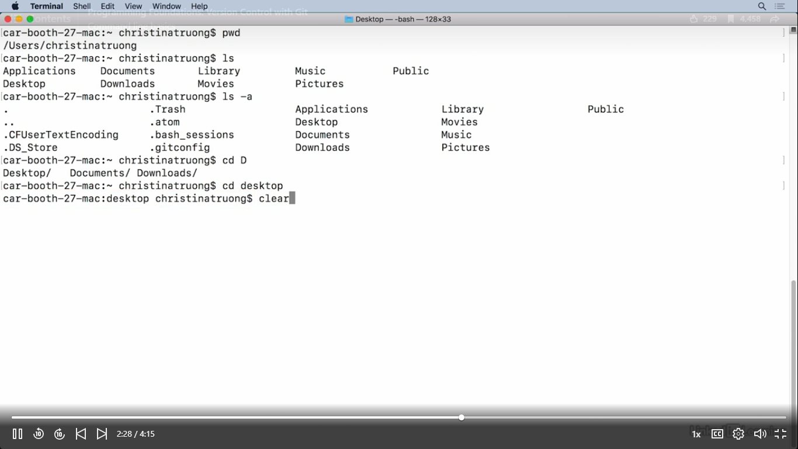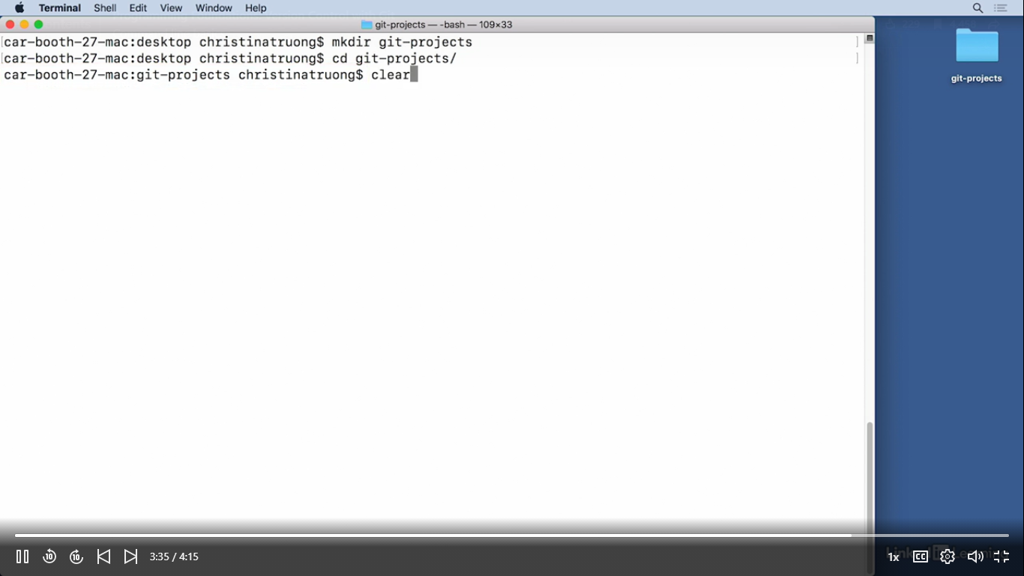

## Command line basics:

* To exit/cancel a command:
  + Quit: ‘q’
  + Type ‘esc’
  + End command: ctrl + C
  + Additional method if all of the above fails: restart Terminal/PowerShell

Configure Git settings:

* Each commit is associated with the author’s identity
* Use ‘git config’ command to set a username and email address

$ git config –global user.name “Your Name”

$ git config –global user.email “[your@email.com](mailto:your@email.com)”

Using global will automatically set the configuration:

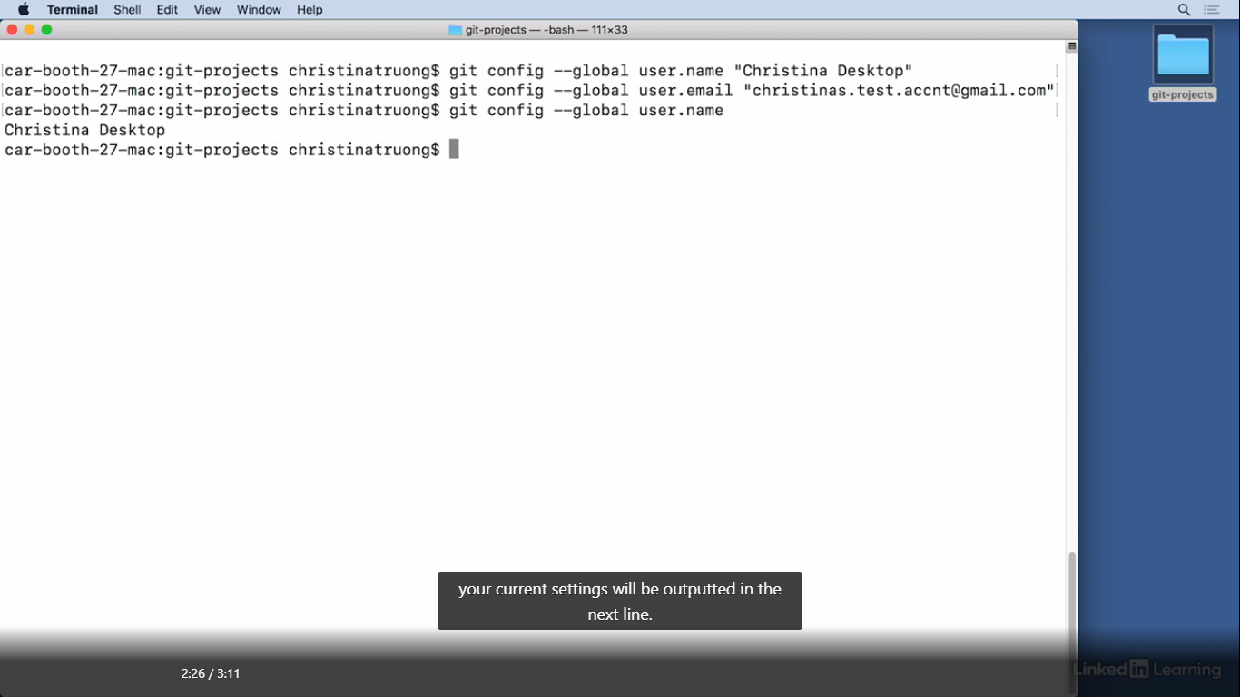

If user wants to use configurations for specific repository:

* Change to that project directory first
* Run same Git fig user name and user email command but without global argument
* User name and email used will only be associated with this specific repository

To set a username and email for specific repository, change to that directory first:

* $ cd specific-directory-name

Then run git config without –global

* $ git config user.name “Project username”
* $ git config user.email [project@email.com](mailto:project@email.com)

Customizing Git: <https://git-scm.com/book/en/v2/Customizing-Git-Git-Configuration>

# Creating local repository:

* Git init: Use git int to initialize a Git repository. Run this command in an un-versioned directory to start tracking changes

Use PWD (Print Working Directory command): to check where you are

# How to change directories?

1. Type cd <space> then drag folder into terminal and press <Enter>
2. Make/creates directory again: mkdir<space>directory name

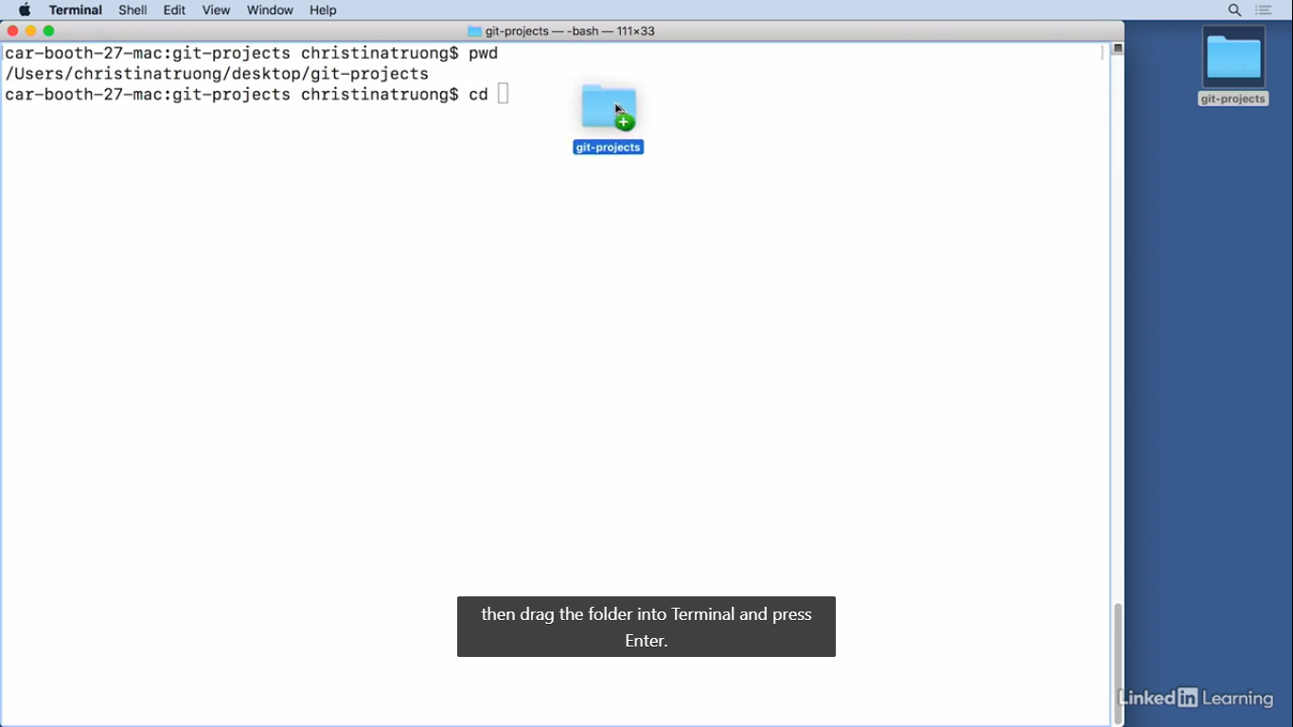

1. Use cd again to change into that directory made: cd<space>directory name
2. Turn folder into a Git repository by initializing it using: git init

To see hidden files use is -a command: is<space>-a

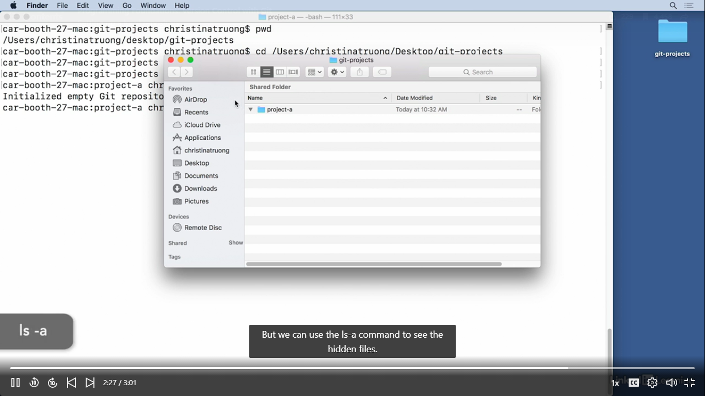

After initializing the repository, all changes will be saved into Git

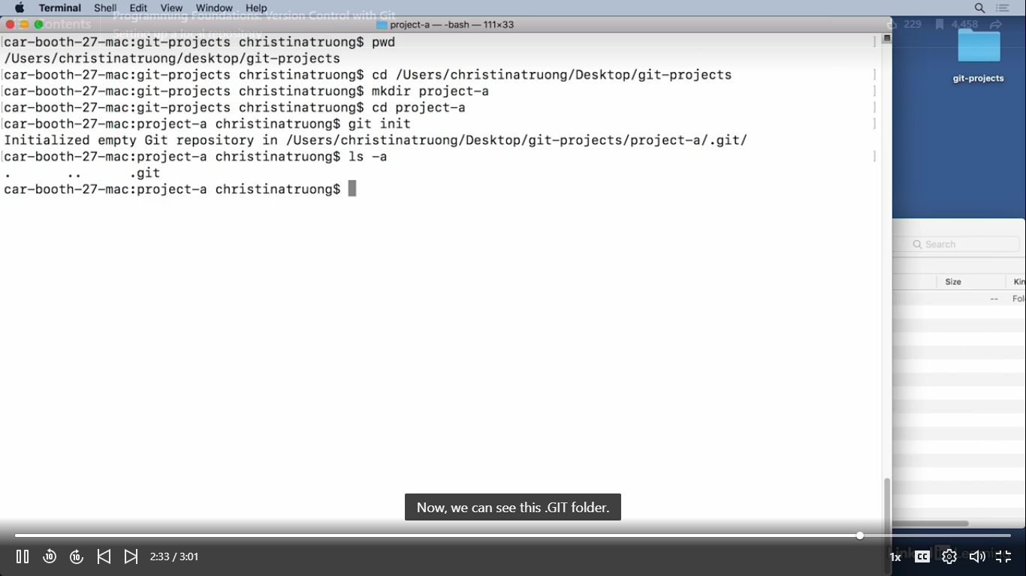

# How to create a remote repository:

1. Require account with a git hosting service: Bitbucket used in the course

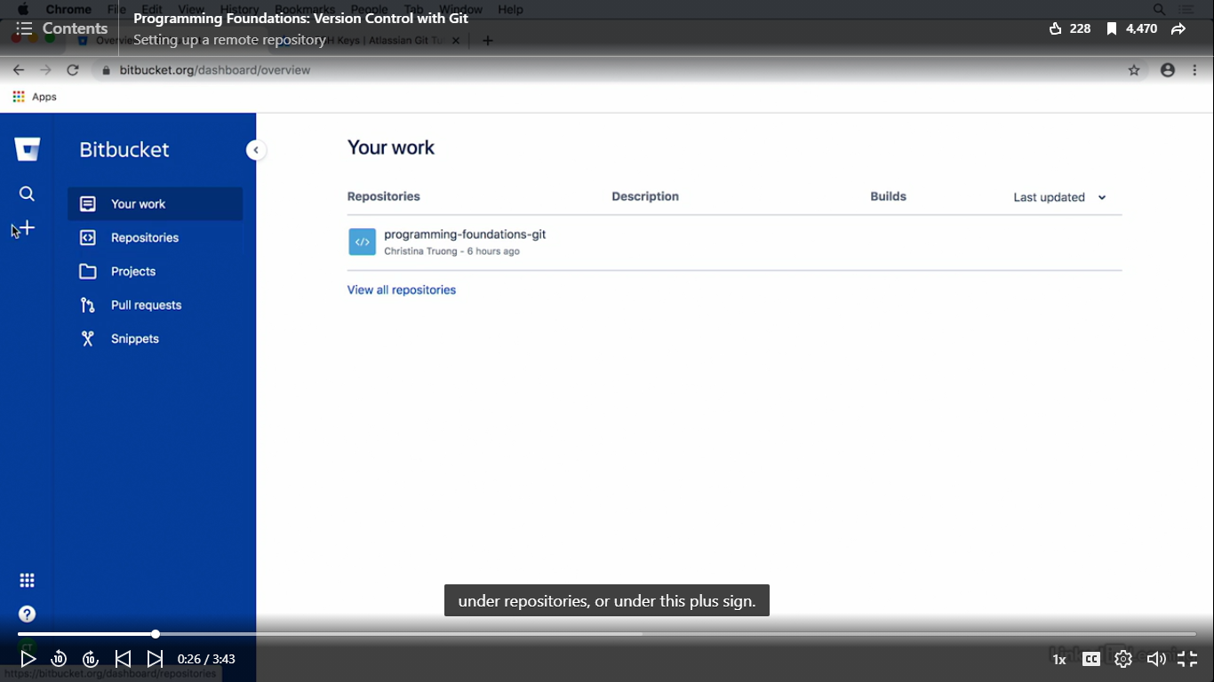

1. Setup a new repository login to user’s account & look for a create repository option

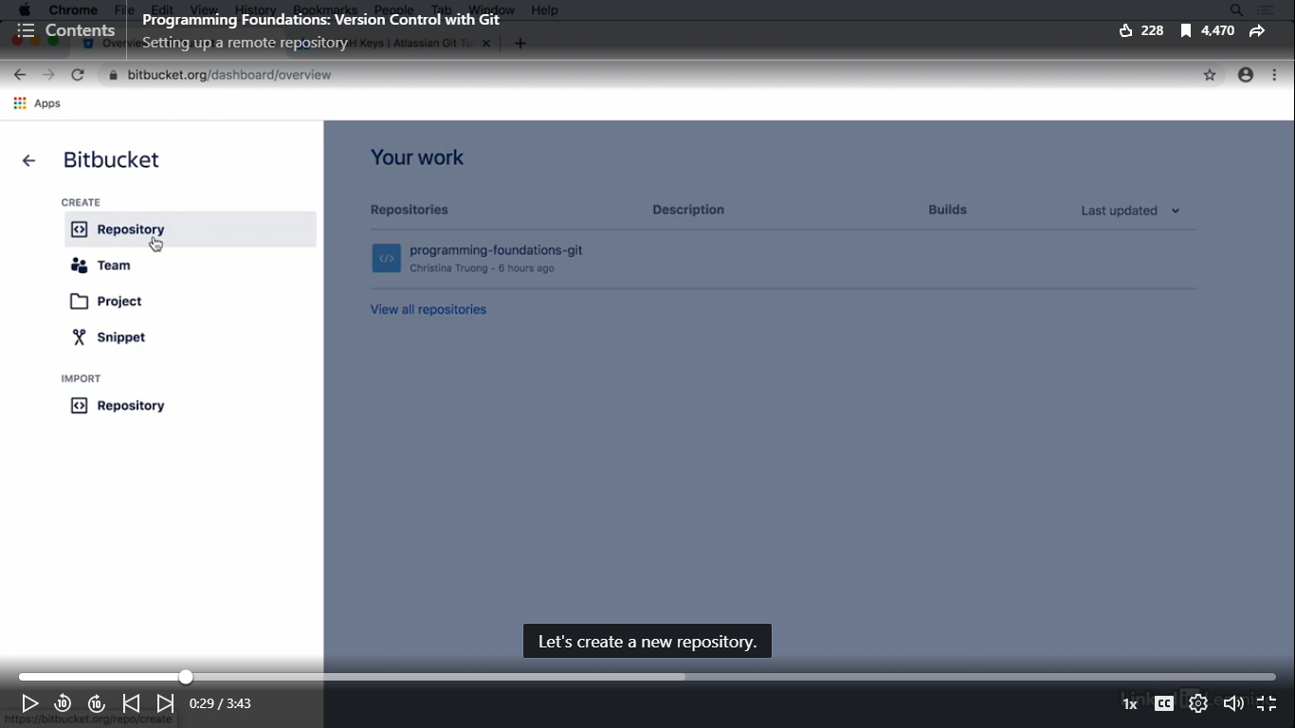

1. README option:

* No: initialise an empty repository
* Yes: with a template, will add a blank README into the repository
* Yes: with tutorial will add some getting started instructions into README files

1. Check the Git option

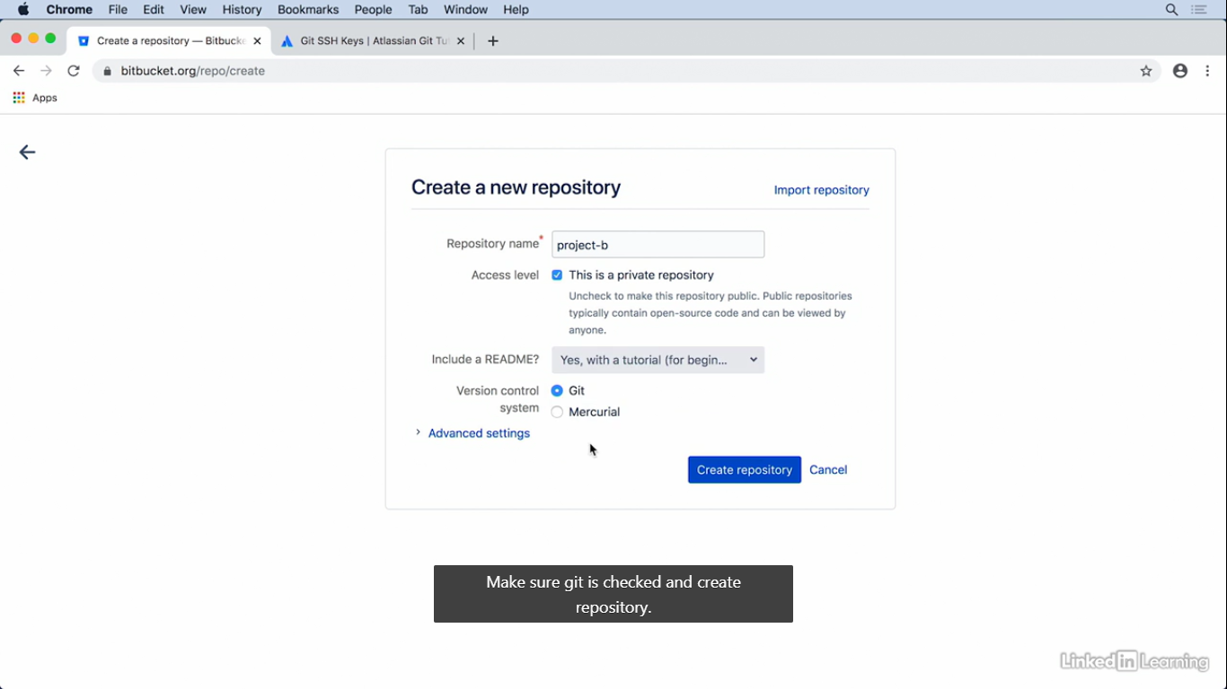

1. Web browser can be edited

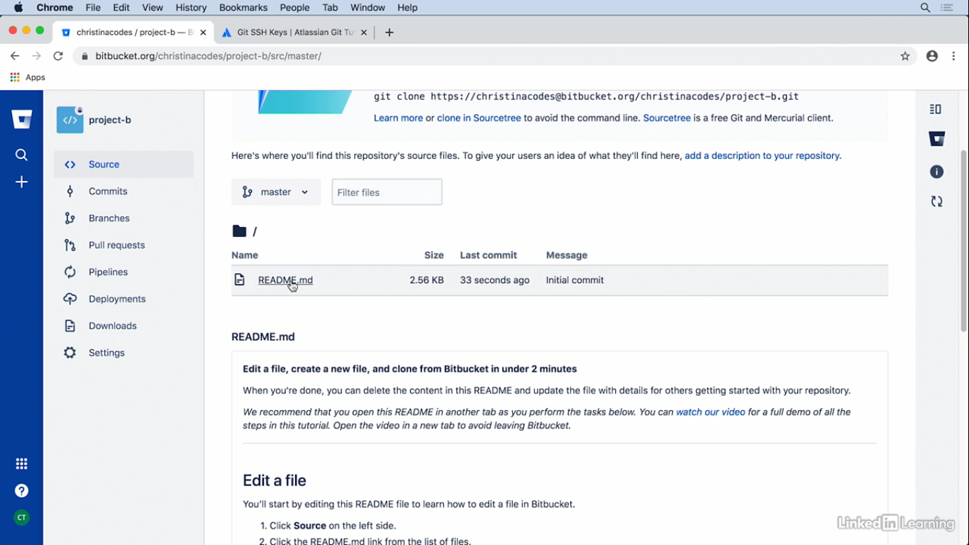

1. Double click on the README.md

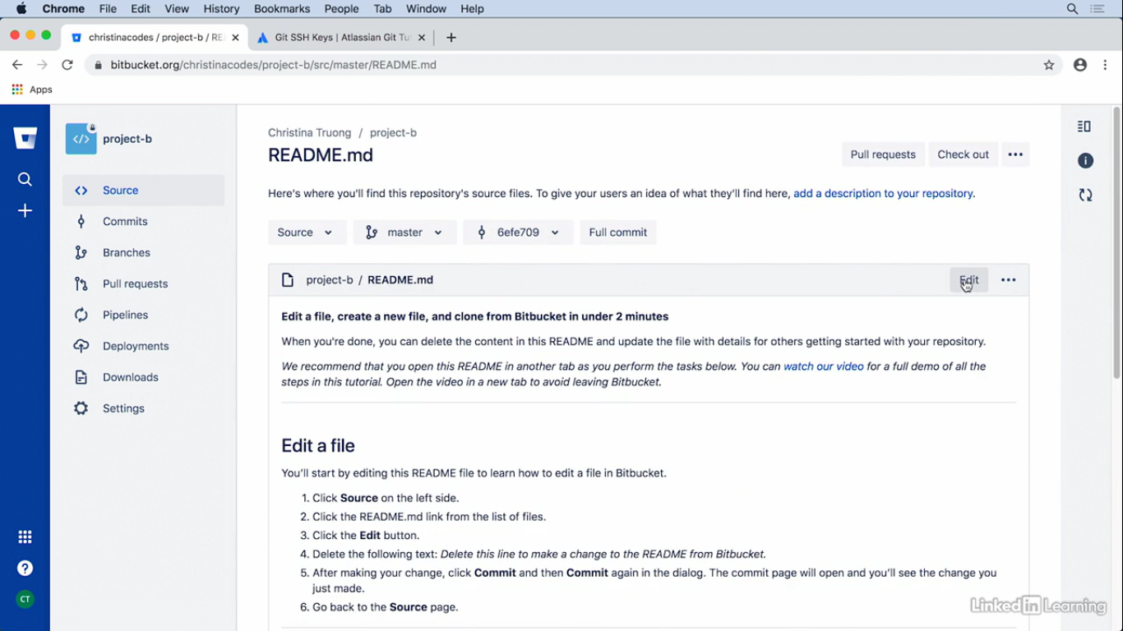

# How to create a local copy from remote repo:

* Create extra copy: Clone copy using git clone command
* Local and remote repo will be connected/sync changes

1. Select clone

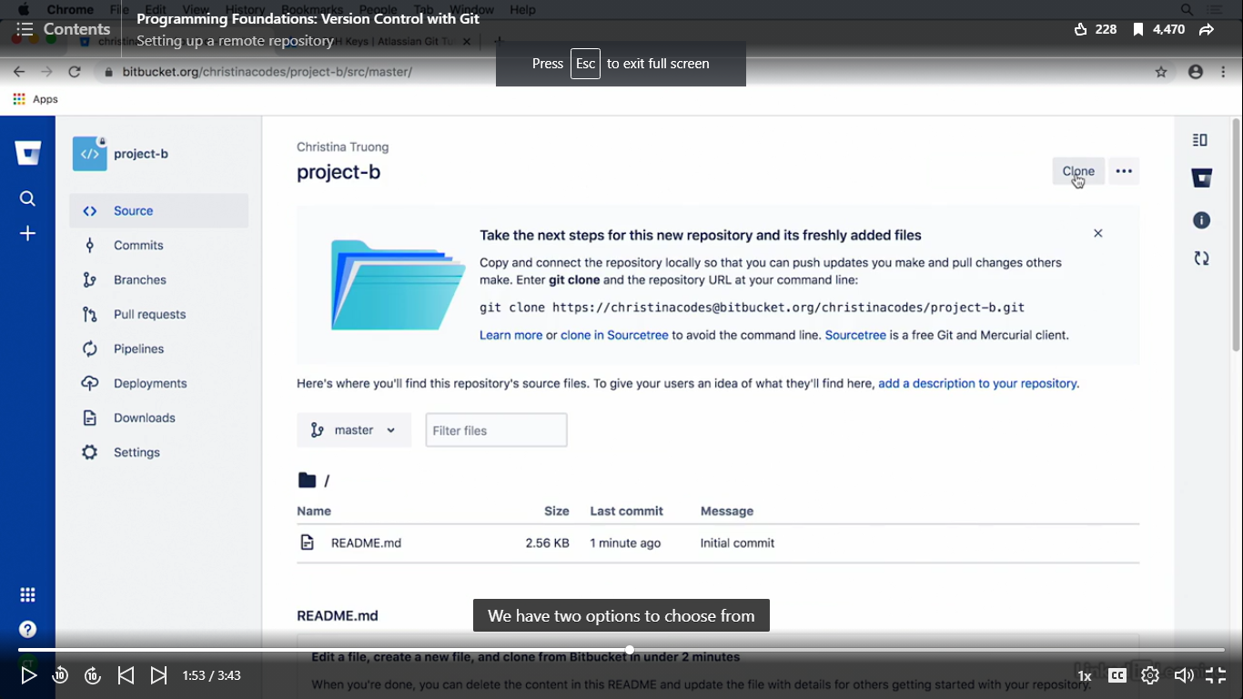

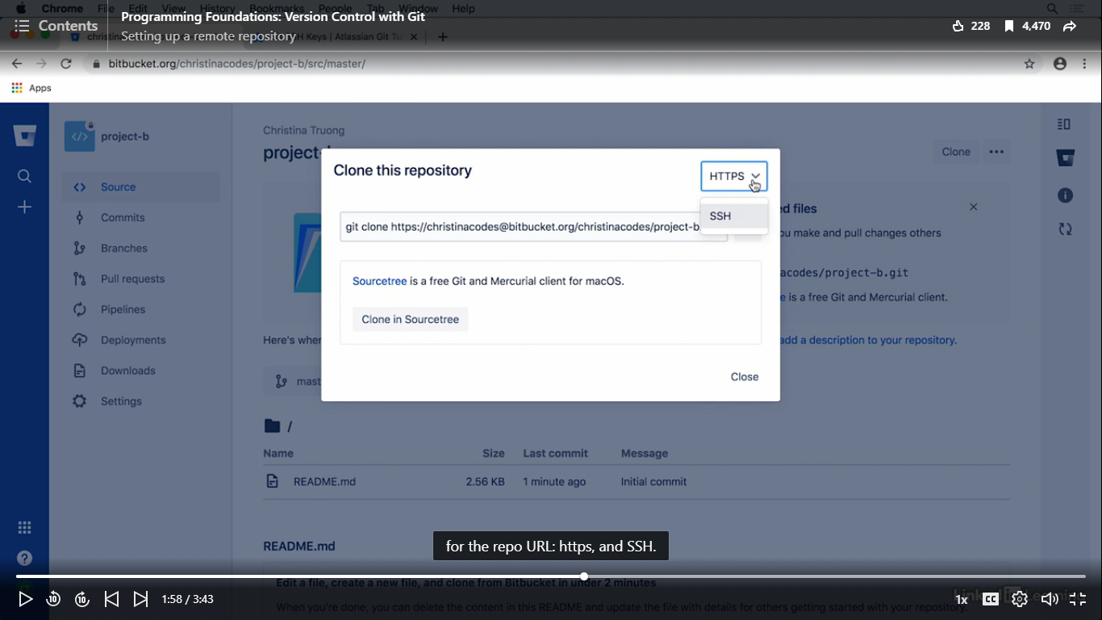



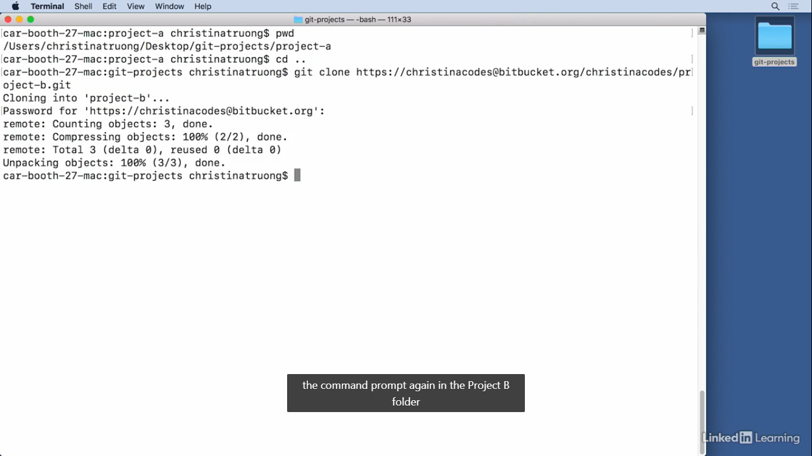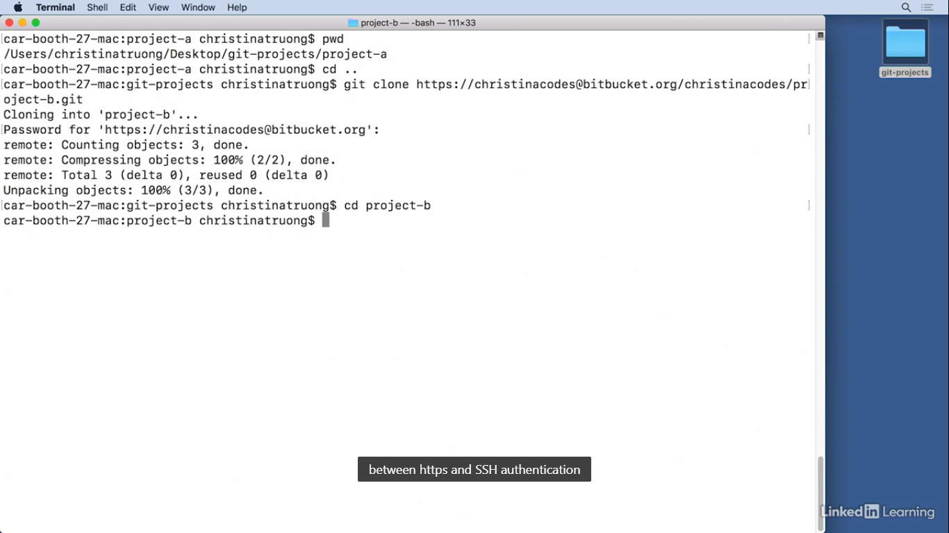



Find out the SSH key

# Make a change to README file in Project B folder using text editor (Atom)

Md file: markup language used to add formatting to elements in a plain text document

**: markdown syntax for bolded text

*: italicized text

##: format the line as an H2 heading

Learn more about markdown: markdownguide.org.

1. Delete all template text
2. Add new title and ## to create a new H2 heading

## Sample title

* Git status: see what’ going on

Origin: remote repository (local and remote repository copies are the same)

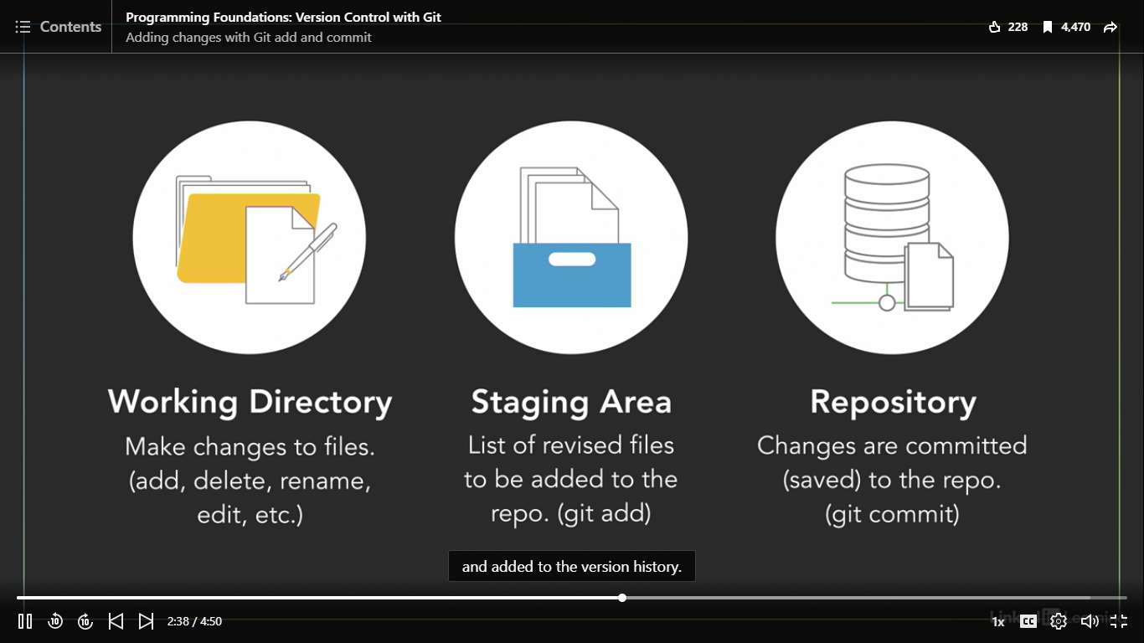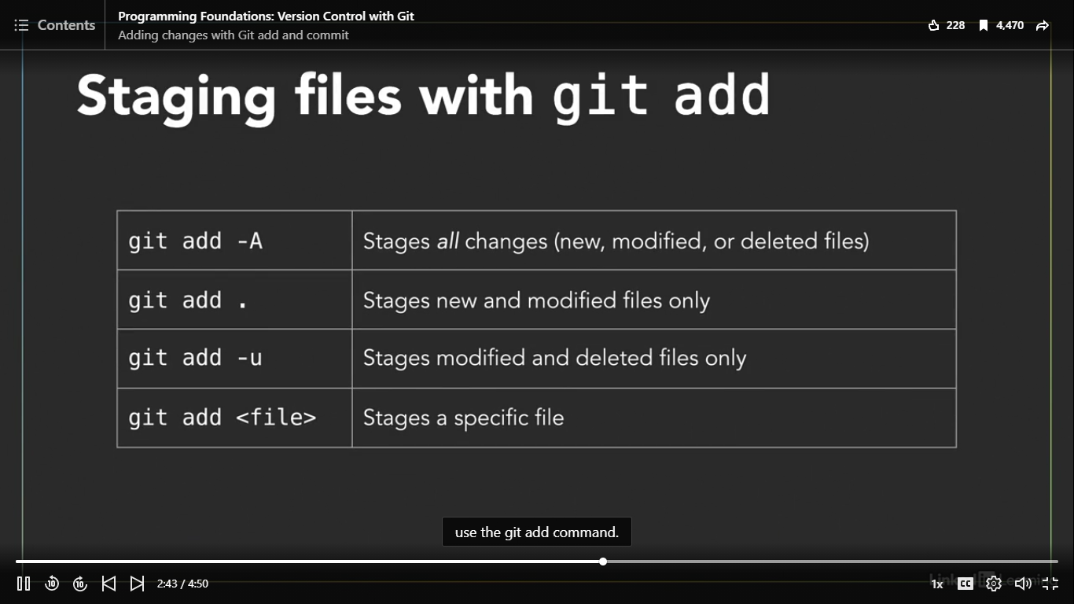

# When README file is at staging area:

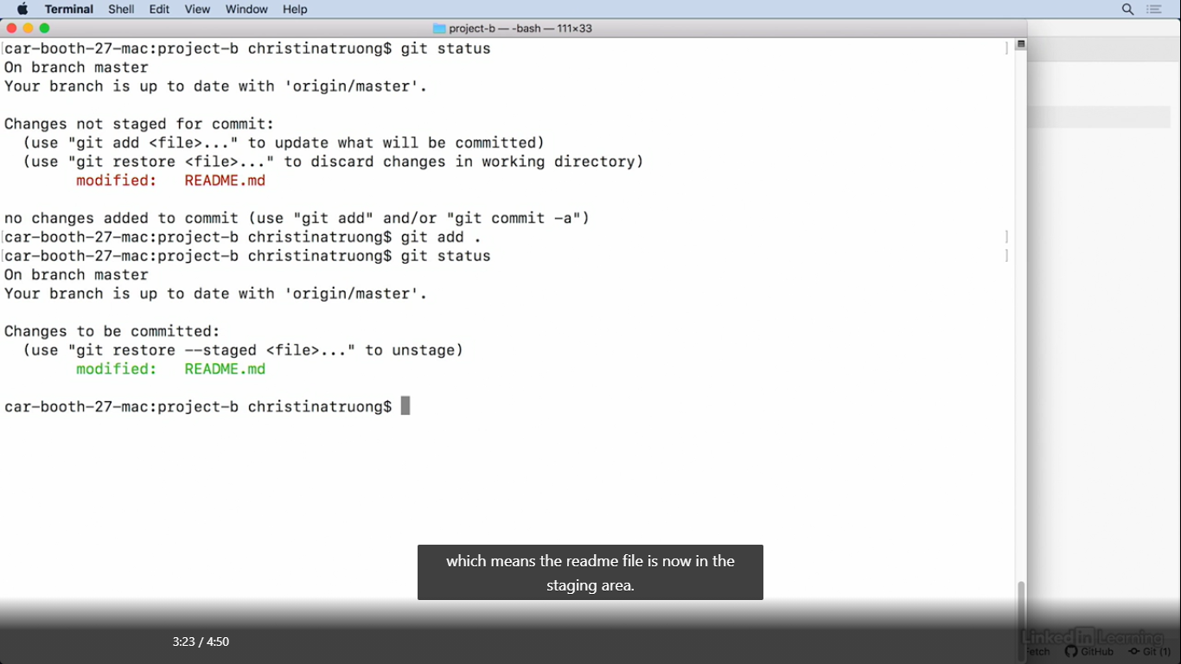

* Git restore: to unstage/unsave the changes

Give short description of what’s contained within the commit**:**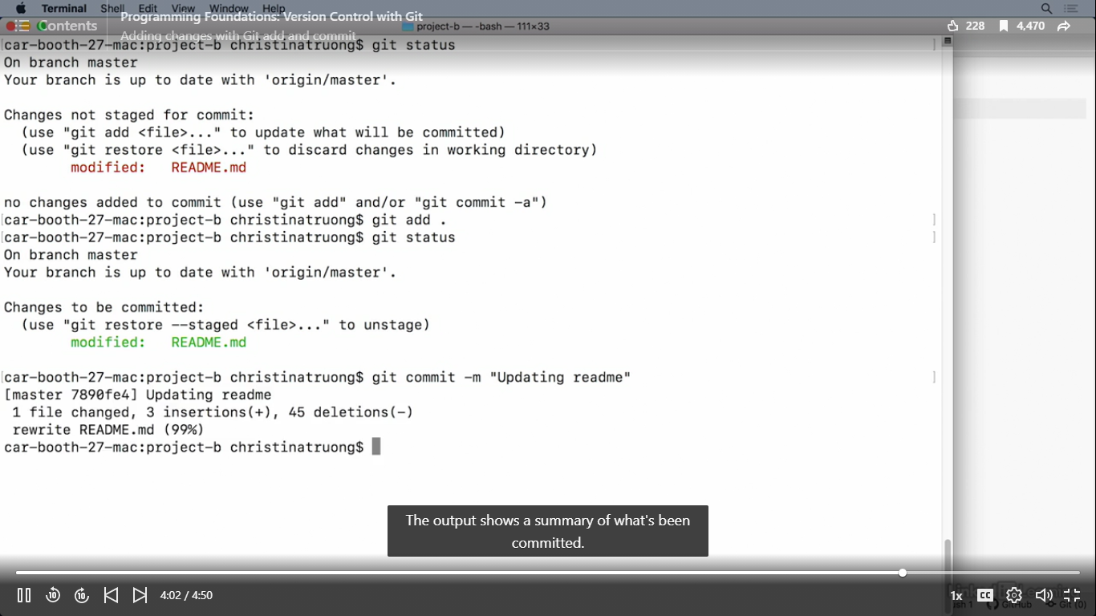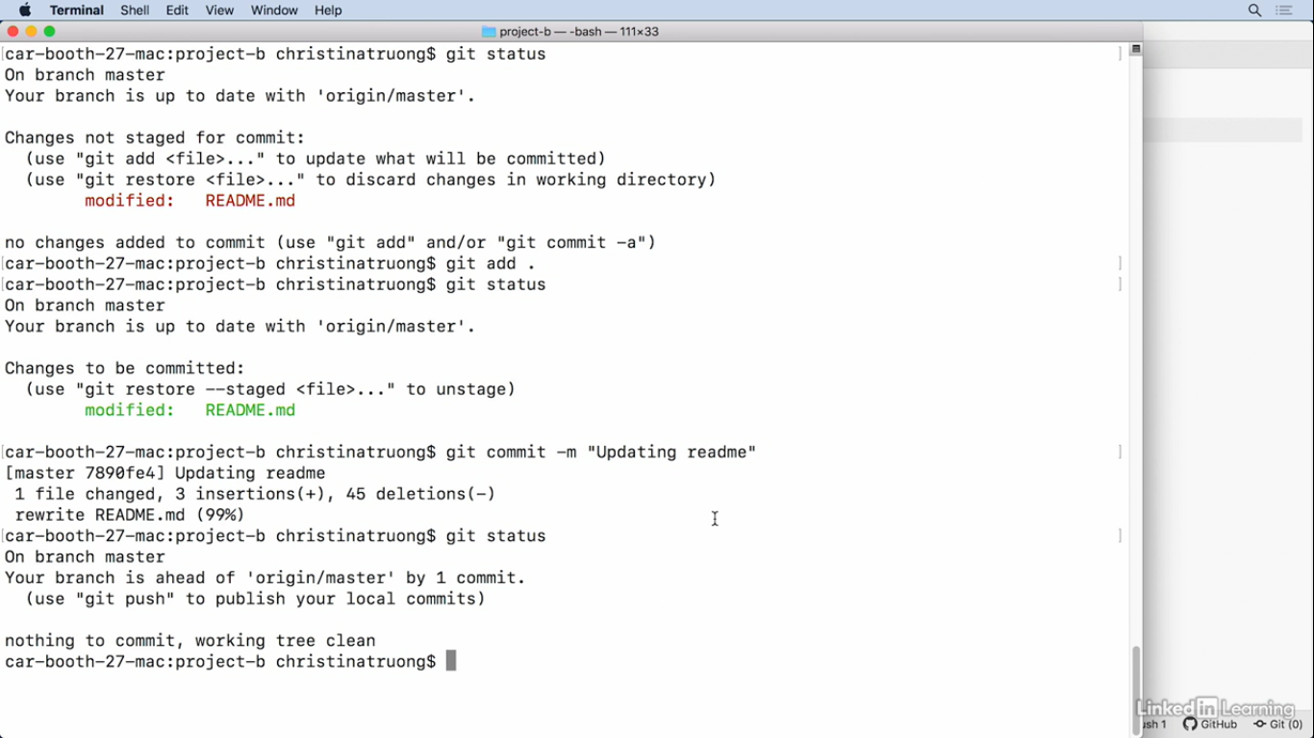



Your branch is ahead of ‘origin/master’ by 1 commit: Local master branch has 1 commit that remote origin master branch doesn’t have

Nothing to commit, working tree clean: no modified files in the working directory

# To sync local and remote repost:

2 additional commands:

* git push:

git push <remote><branch>

git push origin master

* git pull:

git pull <remote><branch>

git pull origin master

# Git workflow:

1. Create a repository
2. Make your changes
3. Add these changes (git add)
4. Commit these change (git command)
5. Push commits to remote repository (git push)
6. Pull/download updates from the remote repository to local repository (git pull)
7. Repeat steps 2 - 6

Notes: Commit often, Commit based on period of time, Write clear commit messages

# How to delete a repository or branch:

1. Login to hosting service
2. Go Bitbucket
3. Settings: **Delete repository**

Git and GUI:

(check out available apps for GUI: <https://git.com/downloads/guis>)

Can use Visual Studio code/ sublime Text/Atom

Sourcetree app used in course = can be connected with bitbucket

Can set the global author details for Git or Mercurial which is another type of version control the Sourcetree supports

This setting is GUI equivalent to adding these details with the git config command

Whatever you set here will override what you added earlier

With the command line, so if you don’t want to change it, leave it blank and select Done

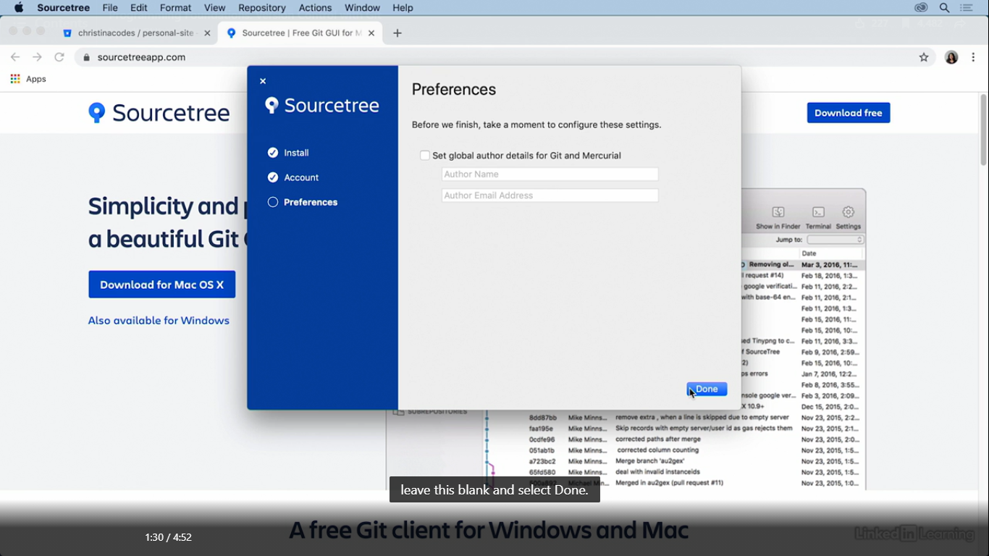

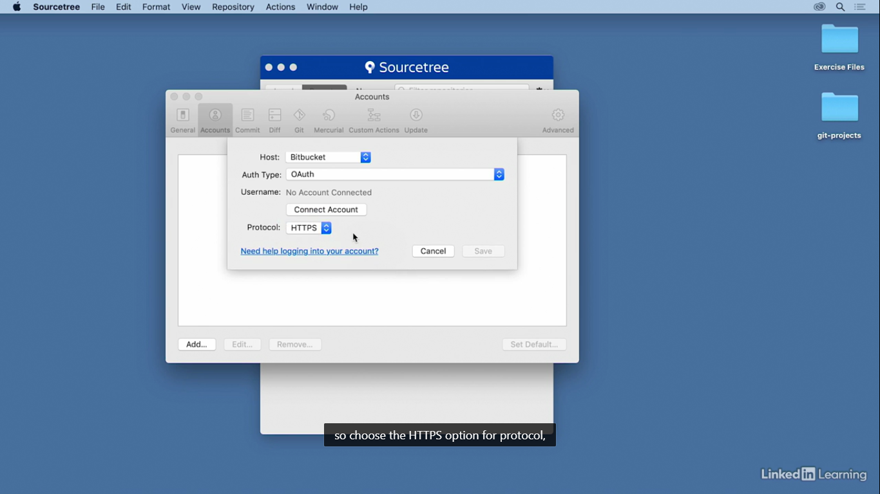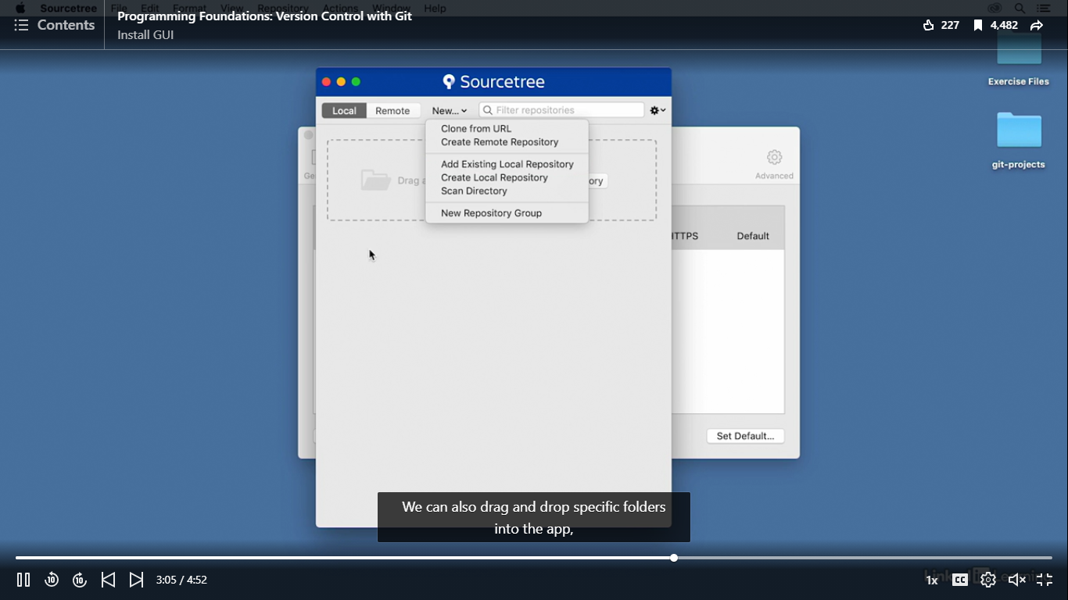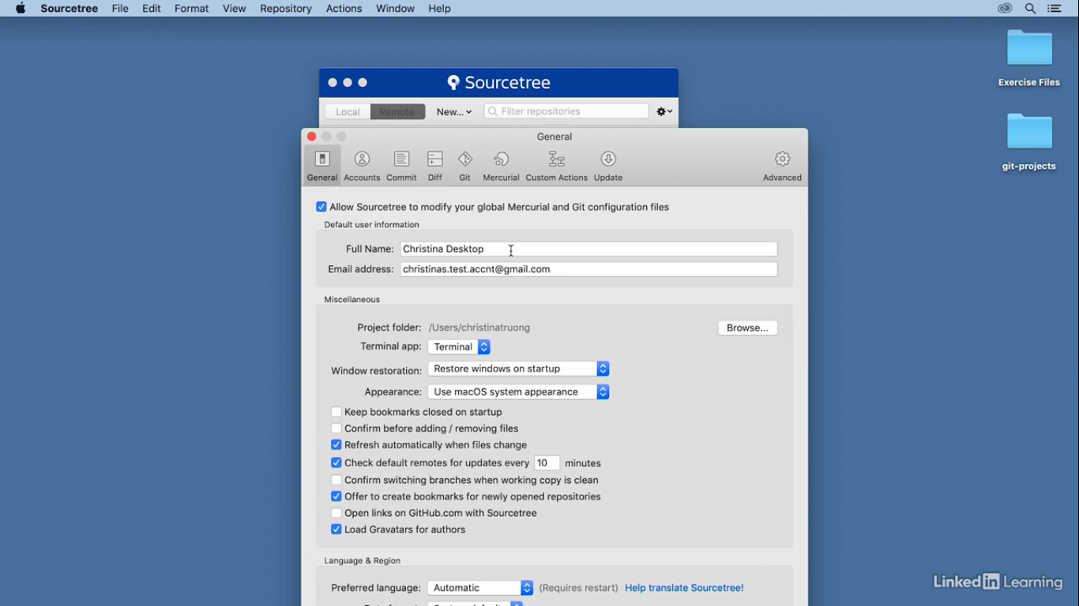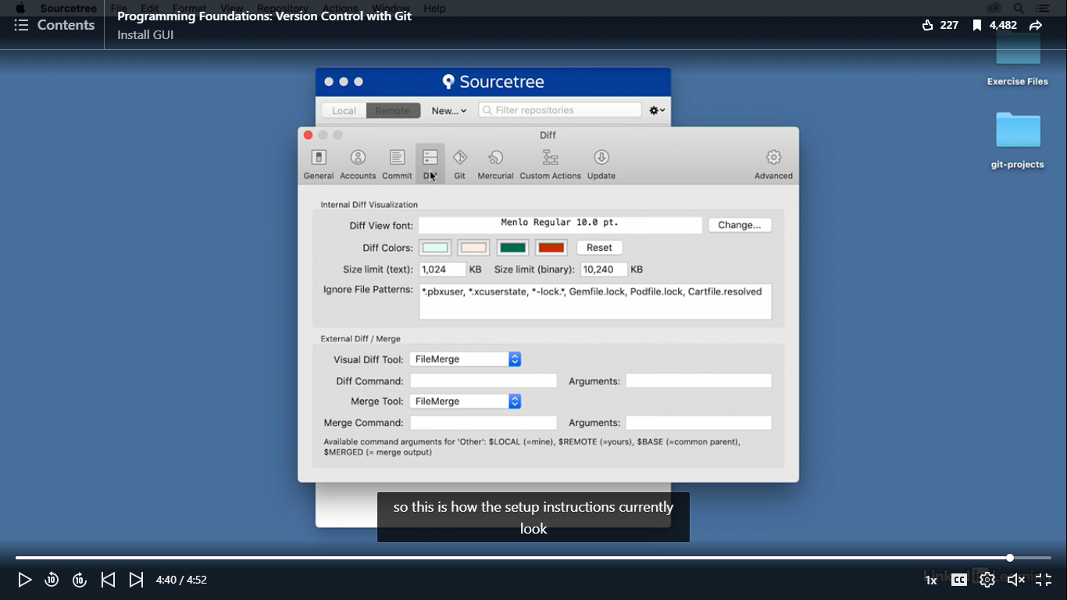

# Working with a repository:

1. By clicking on a project in the bookmarks list: change directories in command lines
2. Create new repositories: clone URL serves the same function as Git clone command

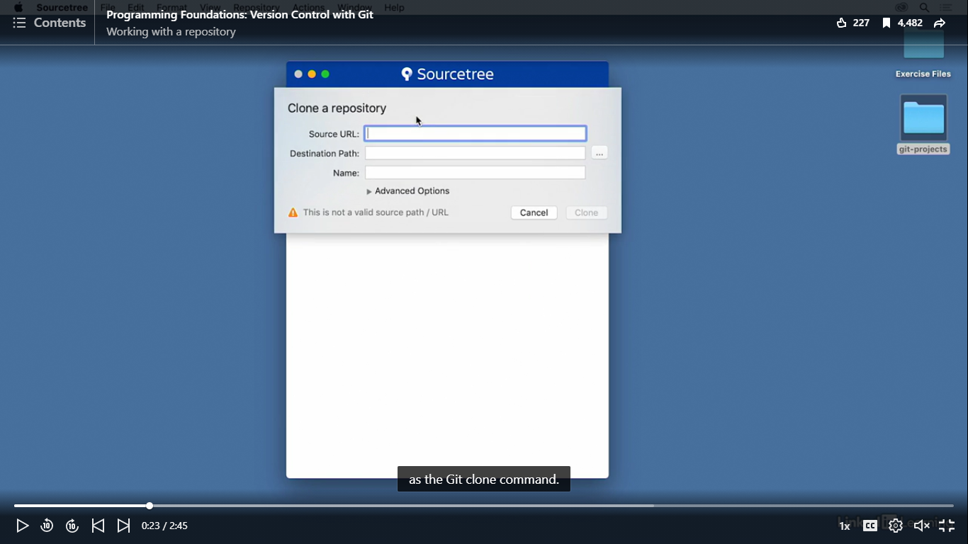

Source URL = repository’s URL

Add existing local repository

Create local repository option & a remote repository path: where to initialize the repository

Create a project then initializing Git in that folder:

1. Navigate to the Git projects folder
2. Create another folder
3. Make the new project the new destination path
4. Select create

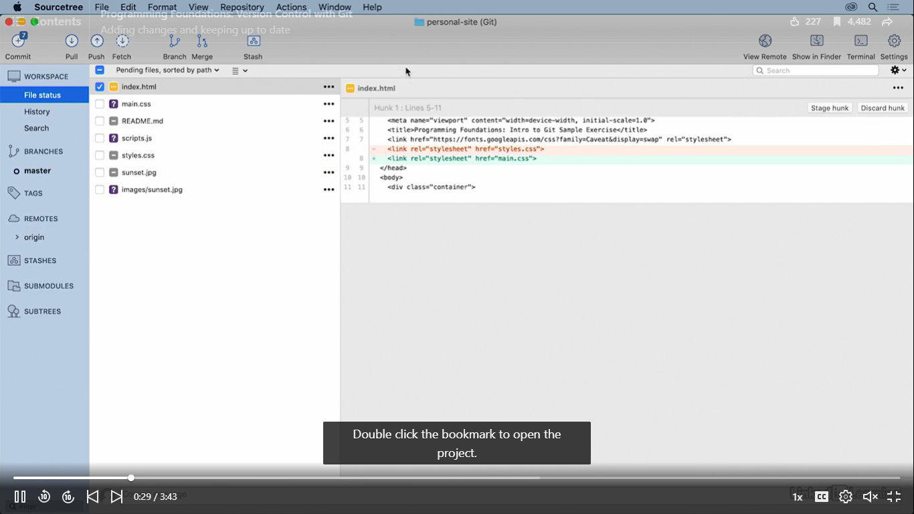

* Yellow: modified file
* Red: deletion
* Green: new addition
* Purple ?: new, untracked file

Multi line icon: change to tree view = adds a folder icon,

Gives a better visualisation of directories and sub directories

Separate the staging files

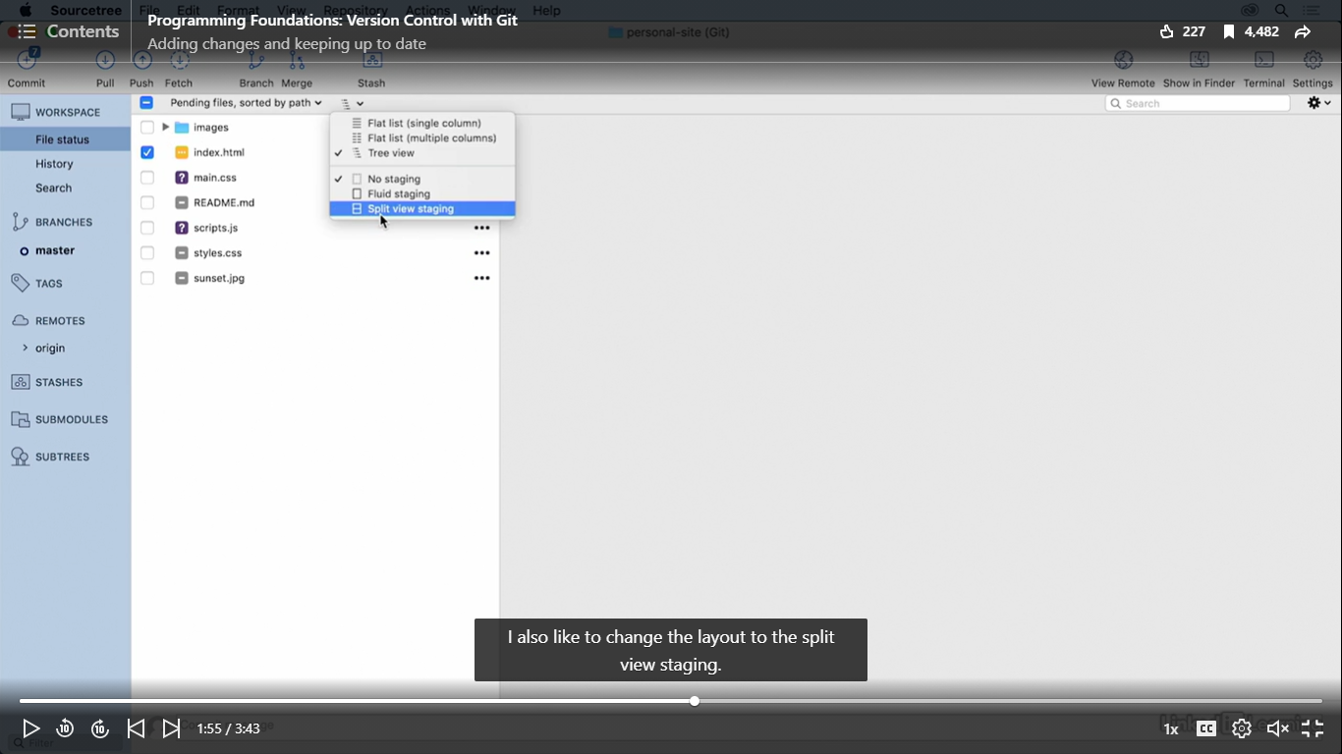

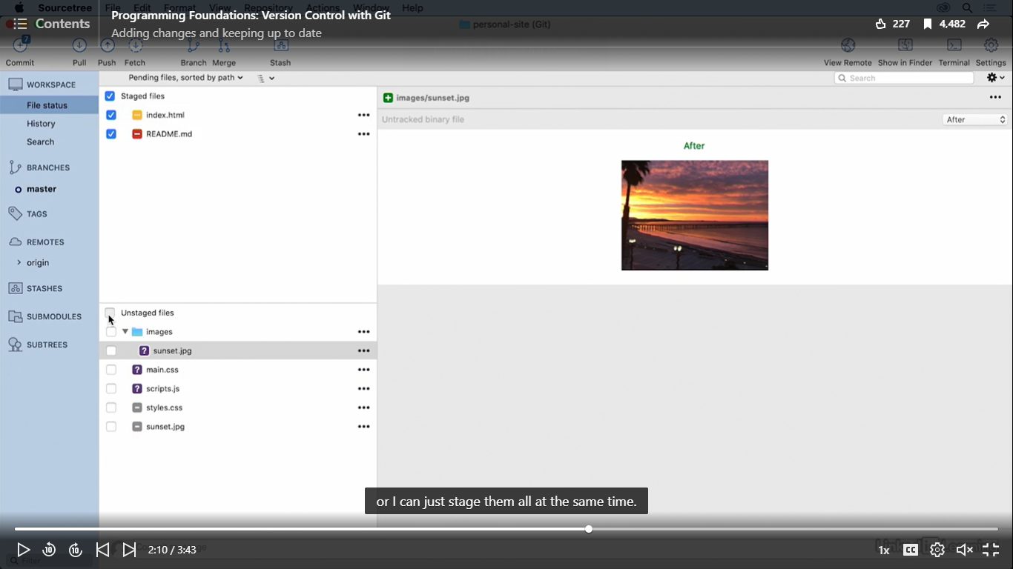To stage a file, check the individual file boxes/ stage all at the same time

# Git branching:

Adding new feature

Instead of working in and committing directly to master branch, all work is completed in a separate branch

New feature will be developed in a designated feature branch and bugs fixes will be in a big fix branch

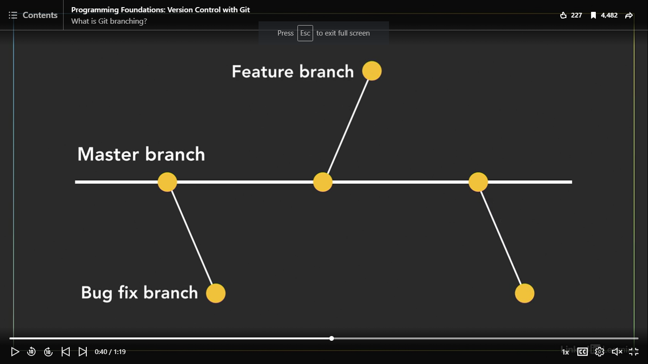

It’s branch is an independent line of development and Git makes no technical distinction between the master branch or any other branch

Can apply all Git commands to any of the branches

After all changes are complete, tested and deem ready to go, it’ll merge back into the master branch: process will ensure the master branch will only contain the most up to date and stable code base

Allows larger projects and teams

# How to create branches with Sourcetree:

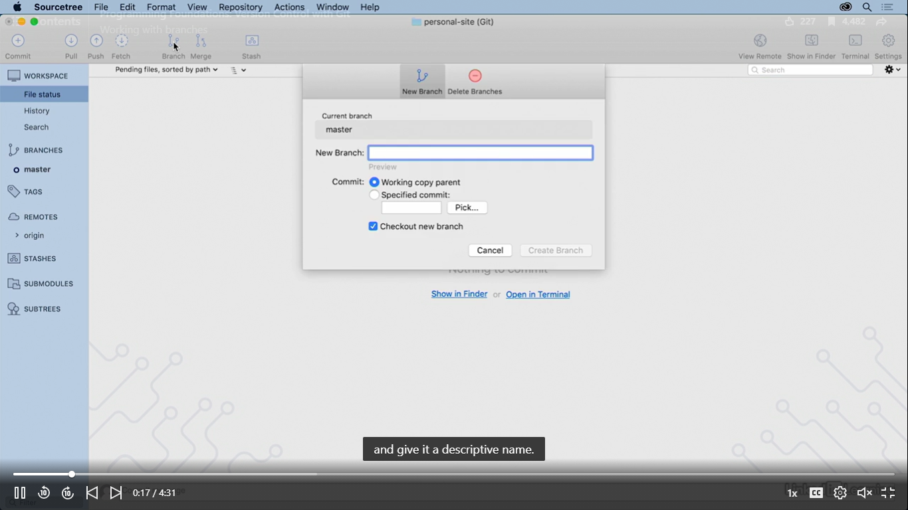

Working copy parent (Default): make a copy from the master branch

Specific commit: make a branch from a specific point in commit history

Double-click other branch to change it/ right-click and select check out

# Add commit message

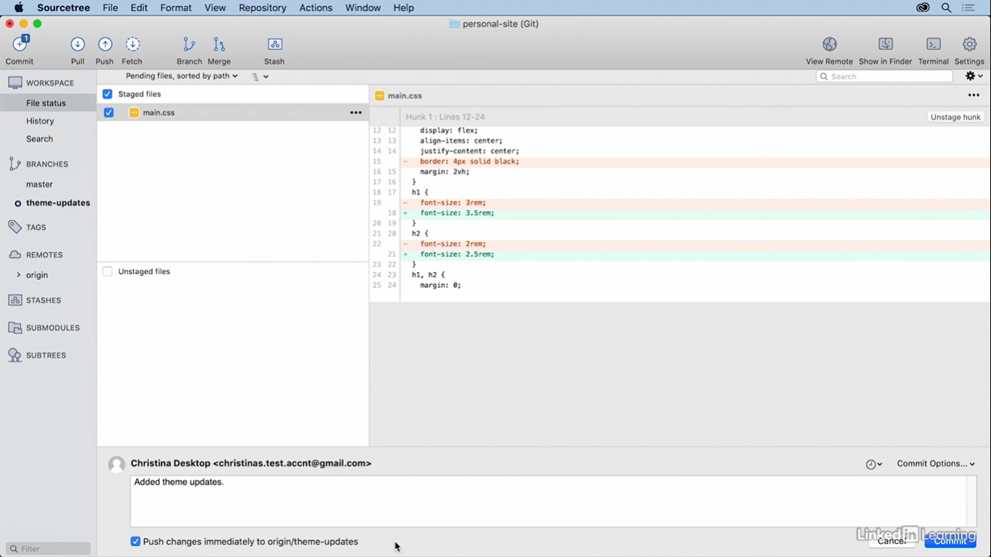

After push commit to the remote repository, it will not go back to master branch= the whole branch will be added to remote repo

From diff computers/ users: able to access the feature branch & master branch from the remote repository

All updates made in feature branches: not seen/changed in master branch

Feature branches: in-progress work (merge back into the master branch )

Master branch: latest and most stable code base is stored

# How to merge branches:

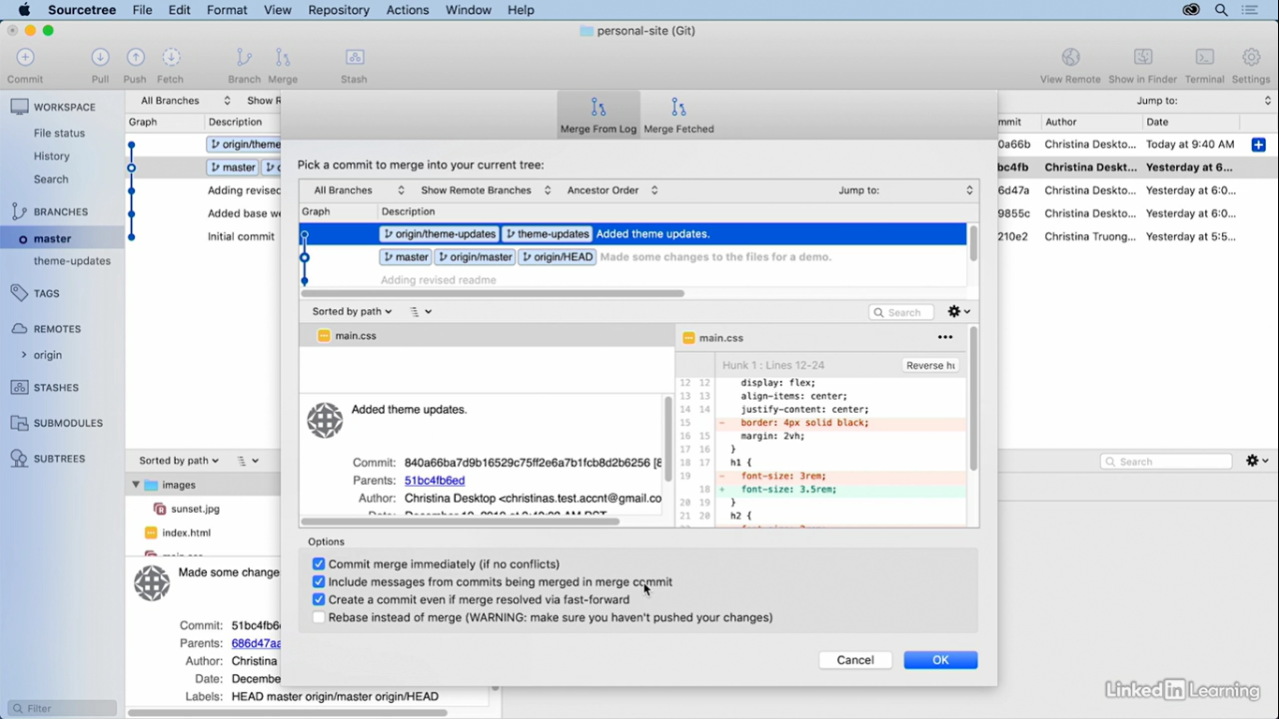

1. Ensure circle beside ‘master’
2. Select ‘Merge’
3. Select feature branch to commit
4. Tick first 3 boxes
5. Select ‘Ok’

Red line: theme update branch

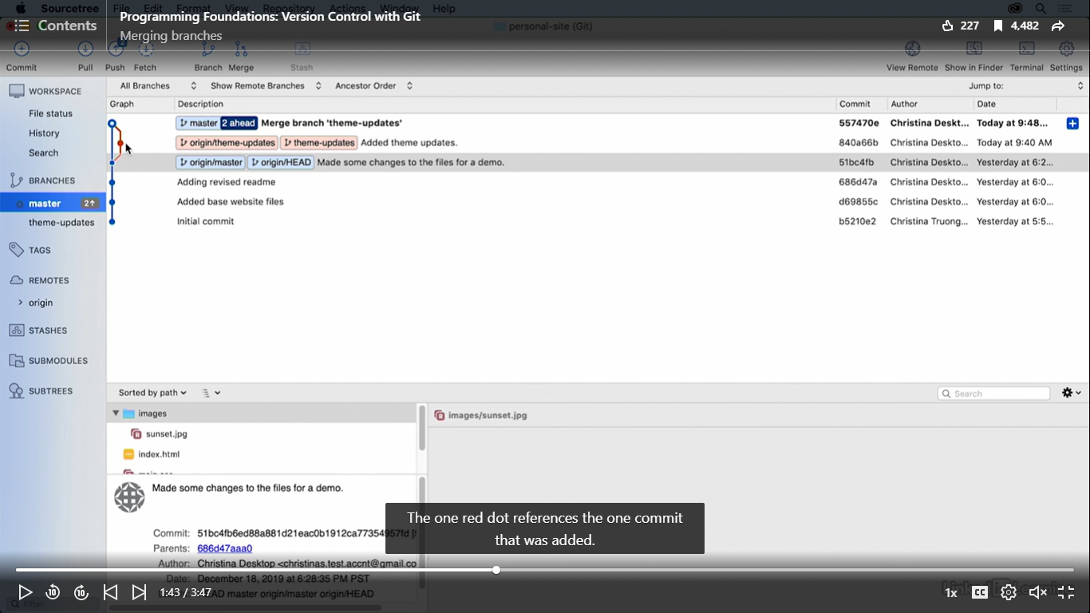

Red dot: 1 commit was added to the feature branch, away from master branch & now merged

Master 2 ahead: local master branch has 2 commits more than remote master branch

# Push commits from local master branch up to remote master branch:

1. Press ‘Push’

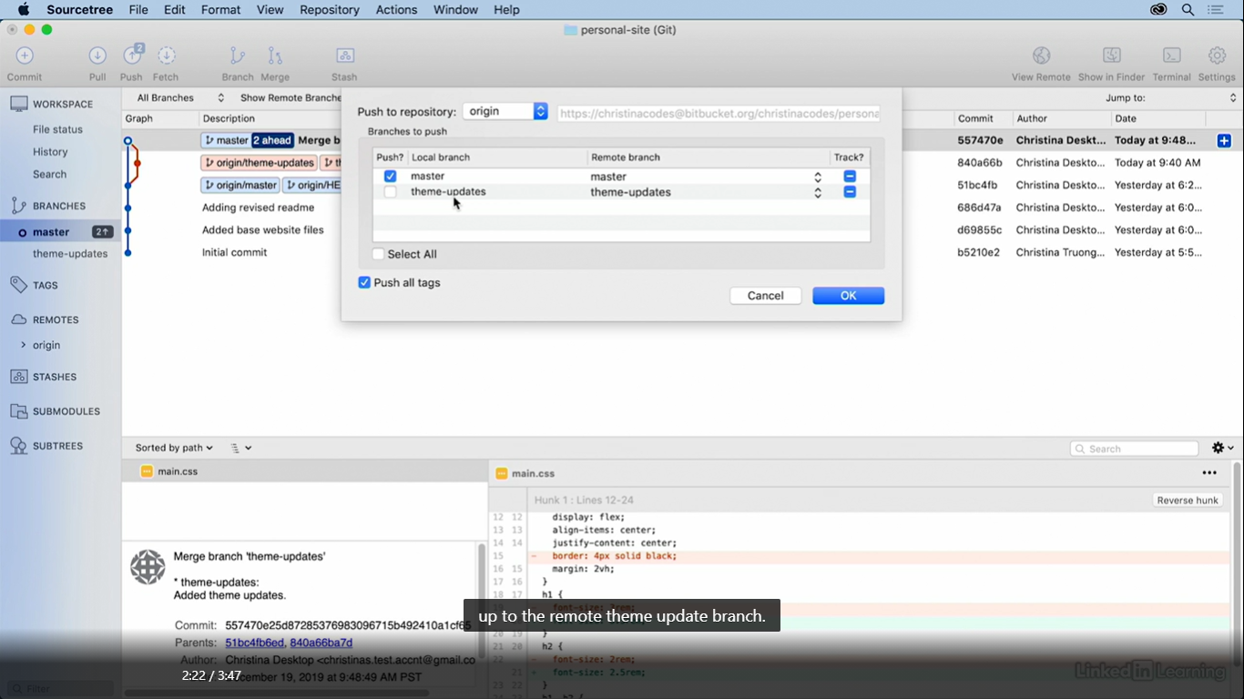

Select feature branch: when user wants to push a change up to the remote feature branch

# Delete branch:

Right click feature branch

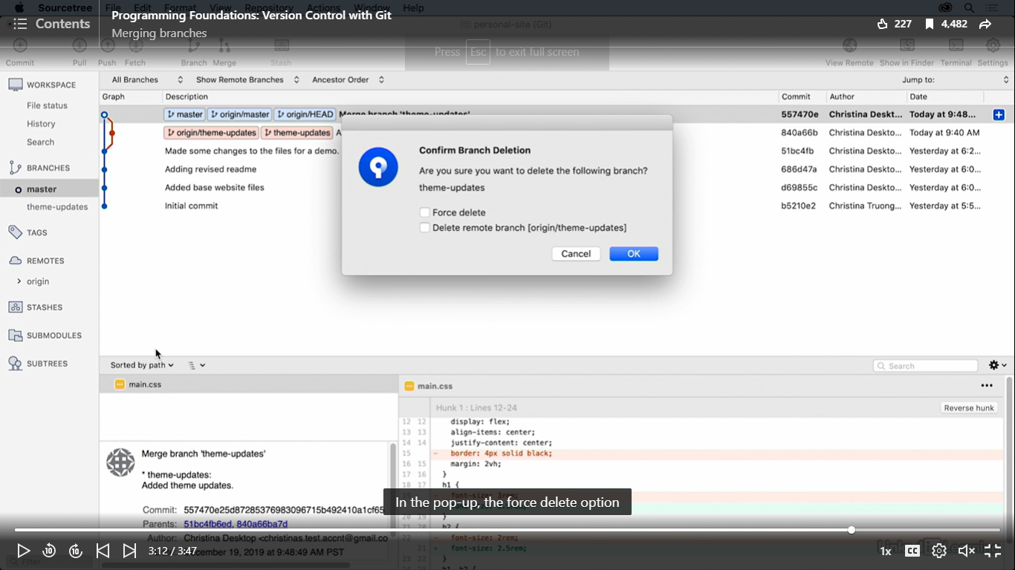

Force delete: deletes branch regardless of its push and merge status

Delete remote branch: deletes both local and remote at same time

Git in Visual studios

# Repository

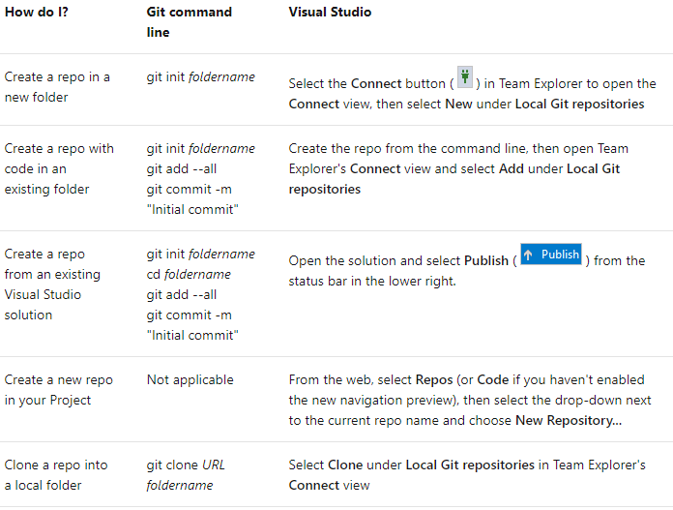

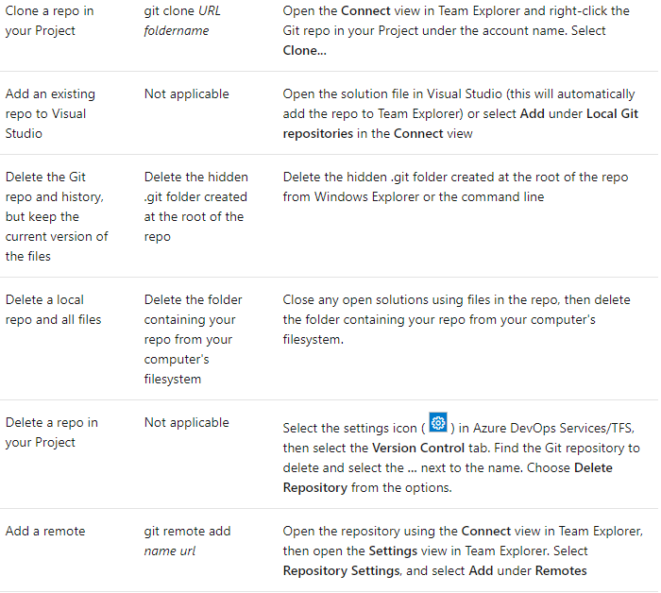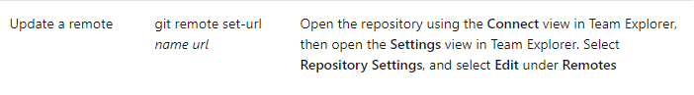

# Branches

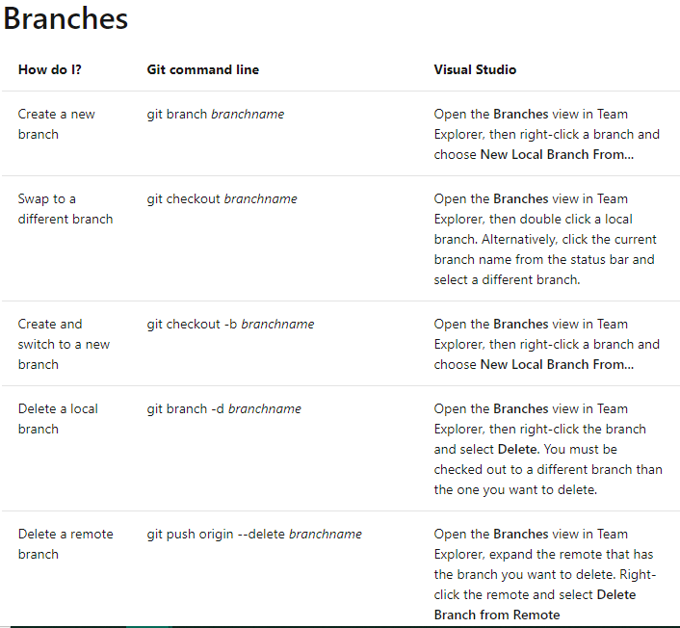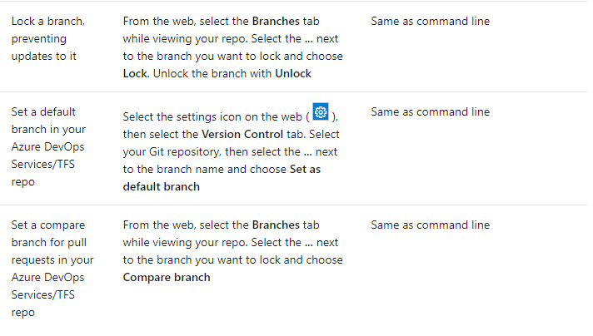

# Commit

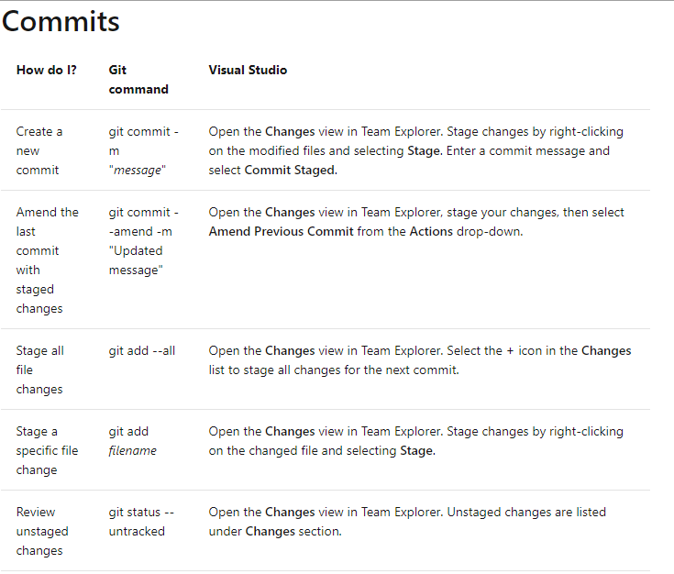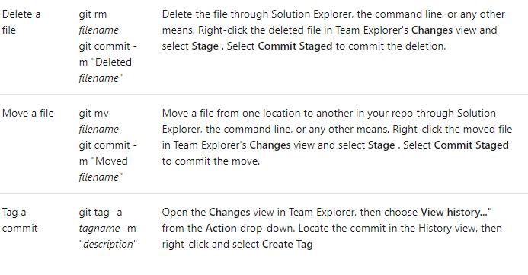

# Compare files and versions

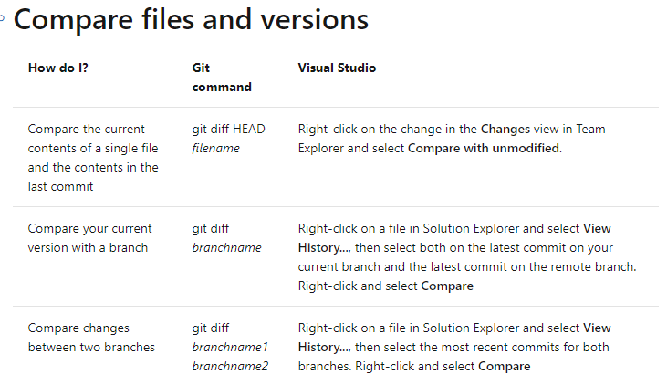

# Sync changes

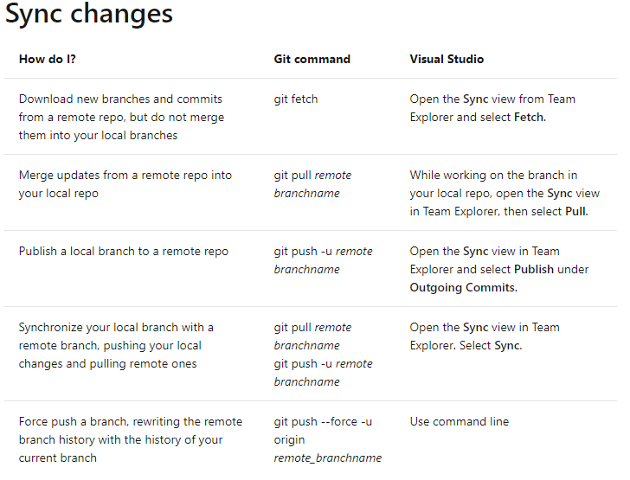

# Merge and rebase

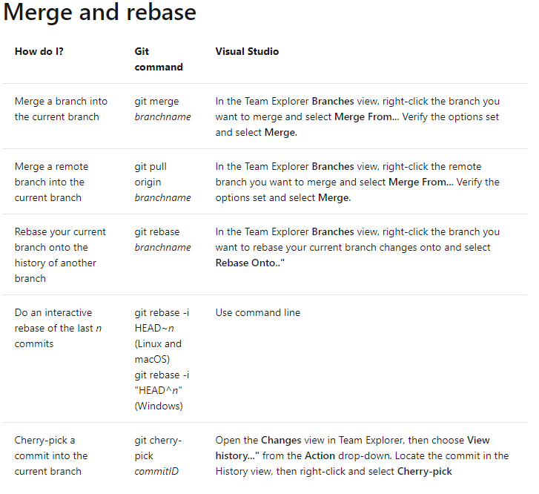

# Undo

